EARLY EXPRESSIONS OF INTEREST WOULD BE GREATLY APPRECIATED

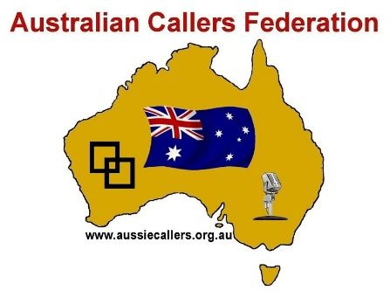
2020 ACF CALLER

CONFERENCE
Monday April 6th to Wednesday April 8th, Leura, NSW
PLEASE ENTER YOUR DETAILS BELOW
NAME(s)………………………………………………………………………………………….…………………………..…………………..
ADDRESS………………………………………………………………………………………………….………….……………………………
PHONE…………………………………………EMAIL………………………………………………..……….…………….………………..
No. of ACF Member/Spouse/Partners ($225.00 each) ………………. ……. Total $………………………………
No. of NON ACF Members/Spouse/Partners ($255 each) ………………….. Total $ ……………………………

POST-CONFERENCE Dance with Randy Dougherty (free for Conference Registrants)
Partner: $15.00 No ……….……… Total ………………………… $20.00 If paid at the door
POST CONFERENCE DINNER SPECIAL
(3 course dinner @ Avalon Restaurant Katoomba and Murder Mystery Entertainment)
No. attending the Dinner/Cruise: $89.00 per person ………………… Total $ …………………….………………
PRE-CONFERENCE DANCE This is a free dance for all delegates and partners.
GRAND TOTAL $..........................................................................

PLEASE SELECT ONE OF THE PAYMENT OPTIONS AND FOLLOW THE INSTRUCTIONS
DIRECT BANKING: BSB: 064420. Account 10028195 Name: Australian Callers Federation
CHEQUES: payable to Australian Callers Federation and posted to:
GARY CARPENTER,
PO Box 97,
The Entrance, 2261 NSW.
Send copy of receipt to: gazacarpenter@gmail.com
GENERAL ENQUIRIES:
Barry Wonson - PO Box 1819, Wollongong NSW 2500. bjwonson@gmail.com

2020 ACF Caller Conference Registration form

